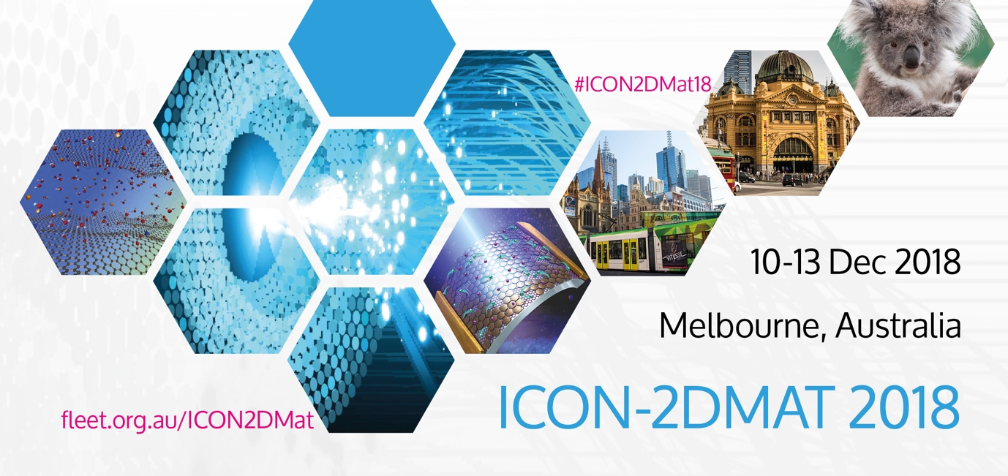
The 4rd International Conference on 2D Materials and Technology (ICON-2DMAT)

December 10-13th, 2018

Nomination Form for

YOUNG SCIENTIST AWARD (YSA)

Instructions

- Nominator please completes and returns the nomination form, not later than 30th October 2018, to: coo@fleet.org.au, with a title specified as “YSA-First name-Last name”.

- Eligibility of Nominee: obtained Ph.D. degree within 10 years

- Supporting Document: (1) one-page brief curriculum vitae; (2) two reference letters; (3) first biography page of passport.

- Any inquiries please address to: coo@fleet.org.au

BIOGRAPHICAL DATA
- Full Name:
- Nationality:
- Date of Birth:

Academic (Tertiary)/Professional Qualifications (state year received)

Appointment Record after PhD
Name of Organization Department & Position Held Period of Appointment

List major awards & honours, chairmanship of conferences/symposia, editorship of journals/books, and invitations to give talks
List research grants secured over the past three years
List graduate students supervised and graduated over the past three years

List of book, book chapters and patents etc.

Expertise and representative publications
Please elaborate the nominee’s research and explain his/her most outstanding representative research, and provide evidence of impact, if any. (of not more than 1000 words)

